Academic Session 2023-24
Students Feedback on Resources
Collected and Analyzed by Dr. Jharna Malviya
B.A.
B.A. (Students Feedback on Resources)

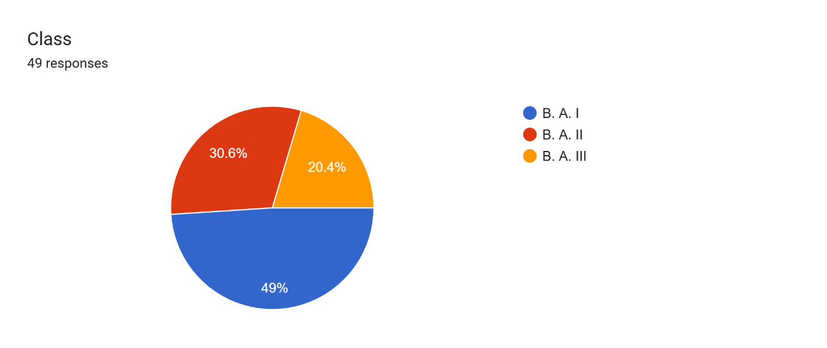

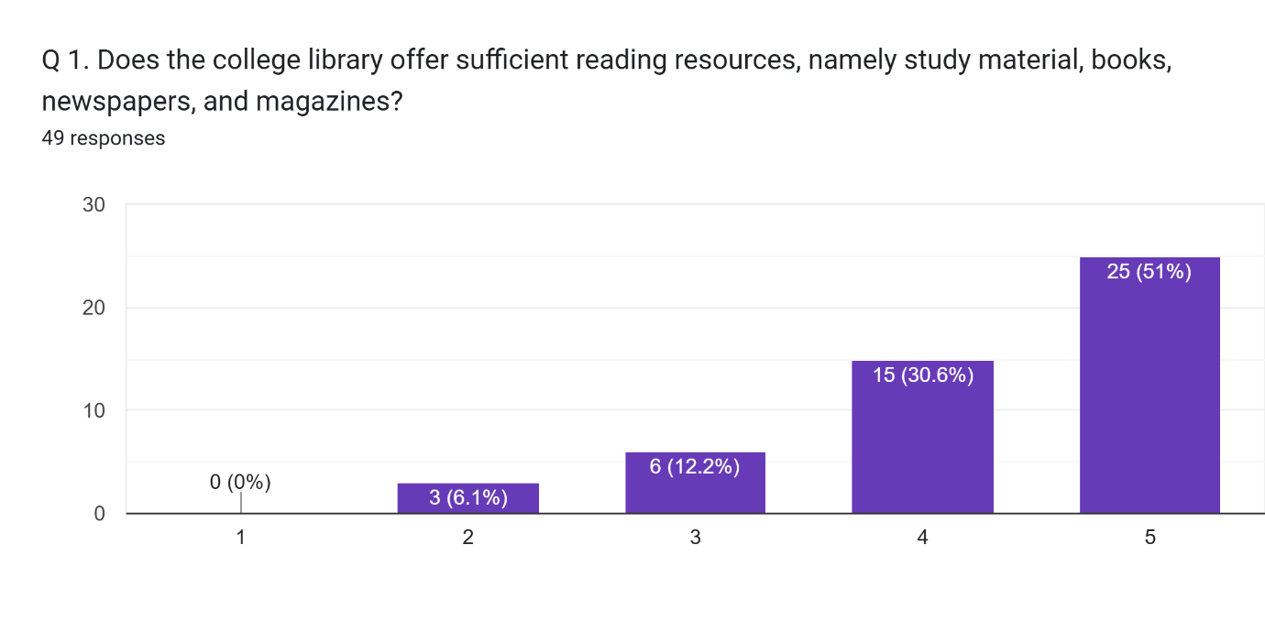

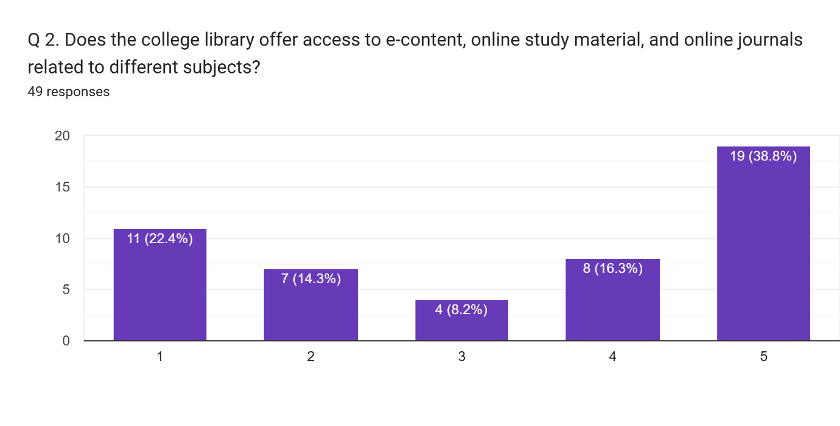

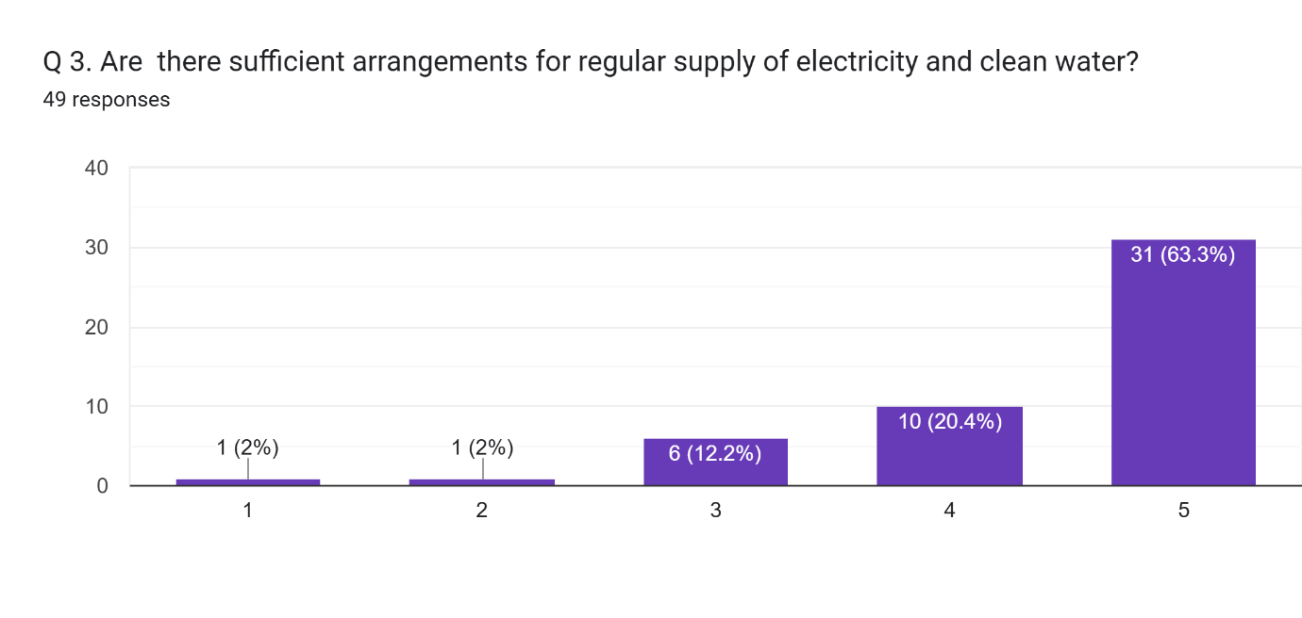

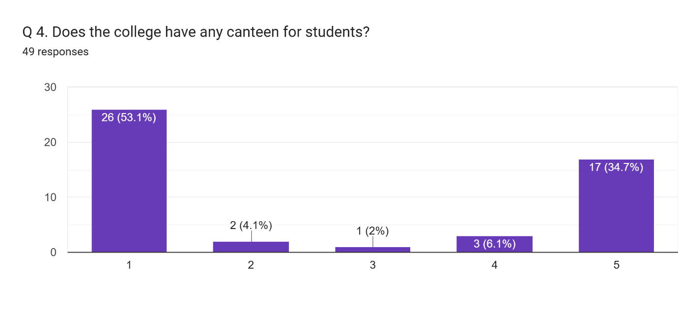

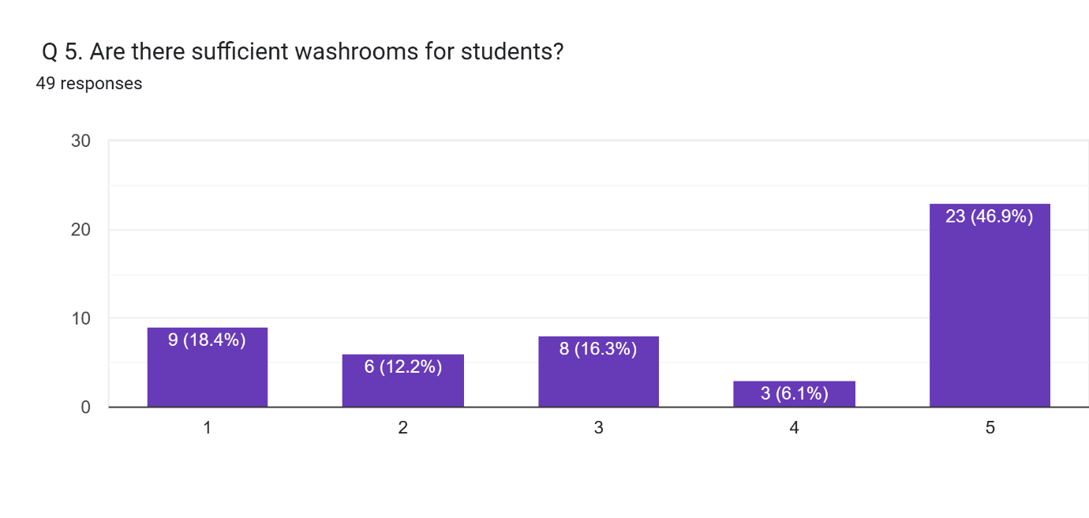
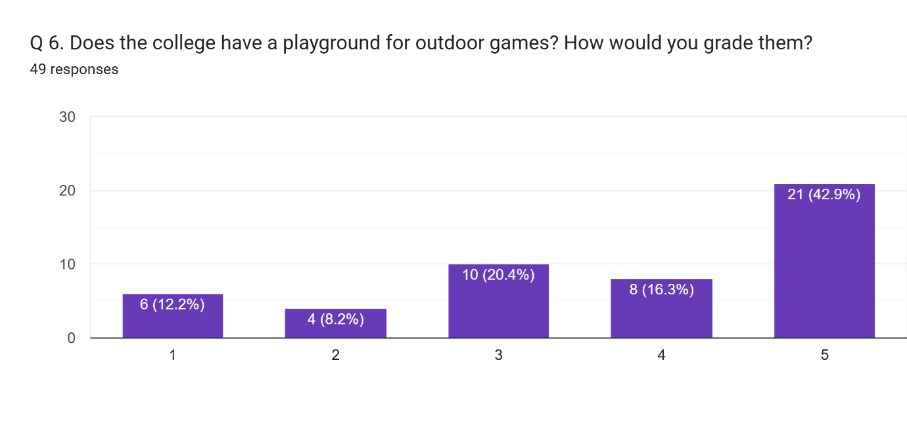

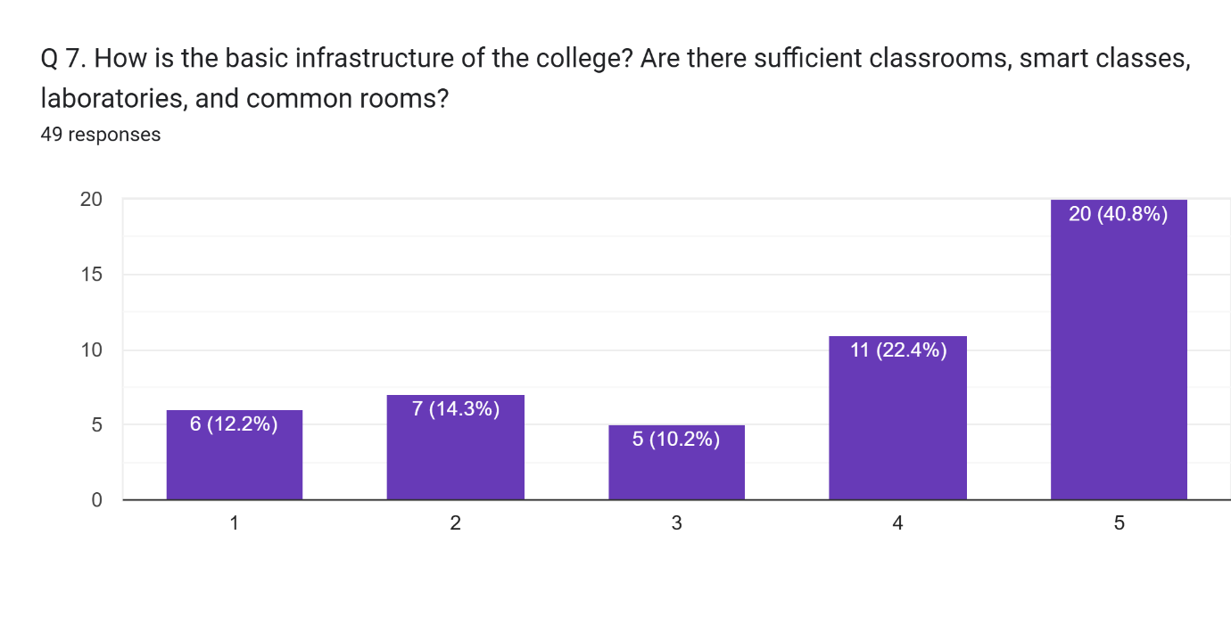
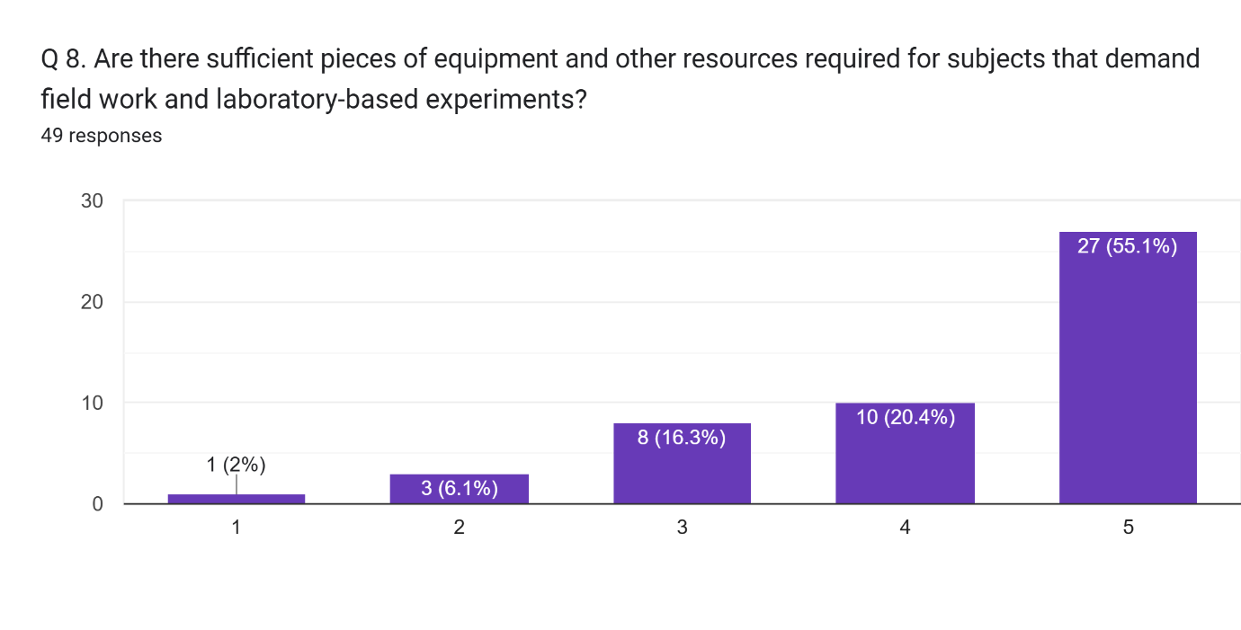

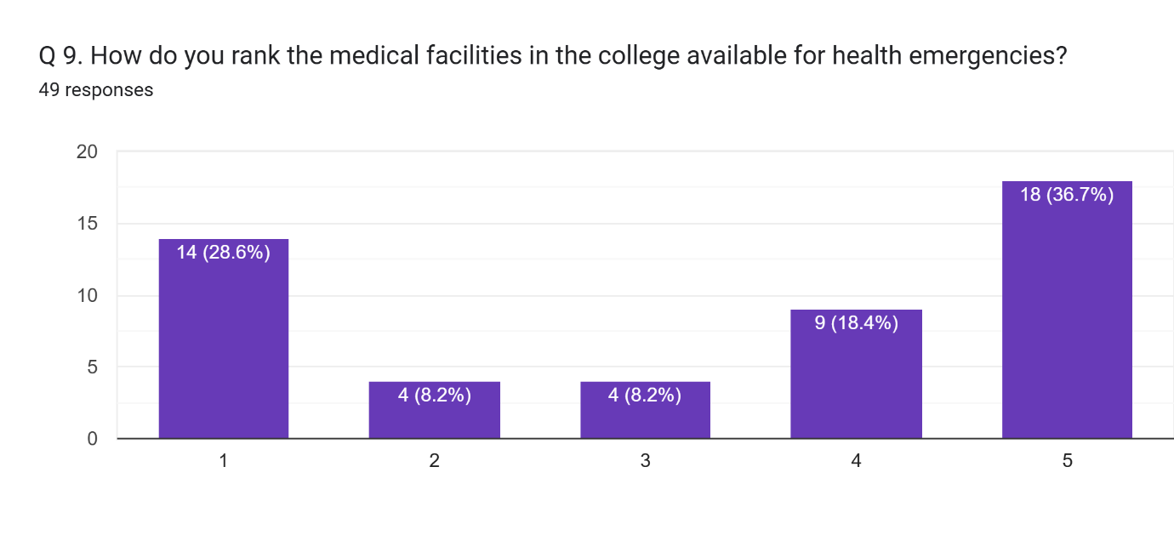

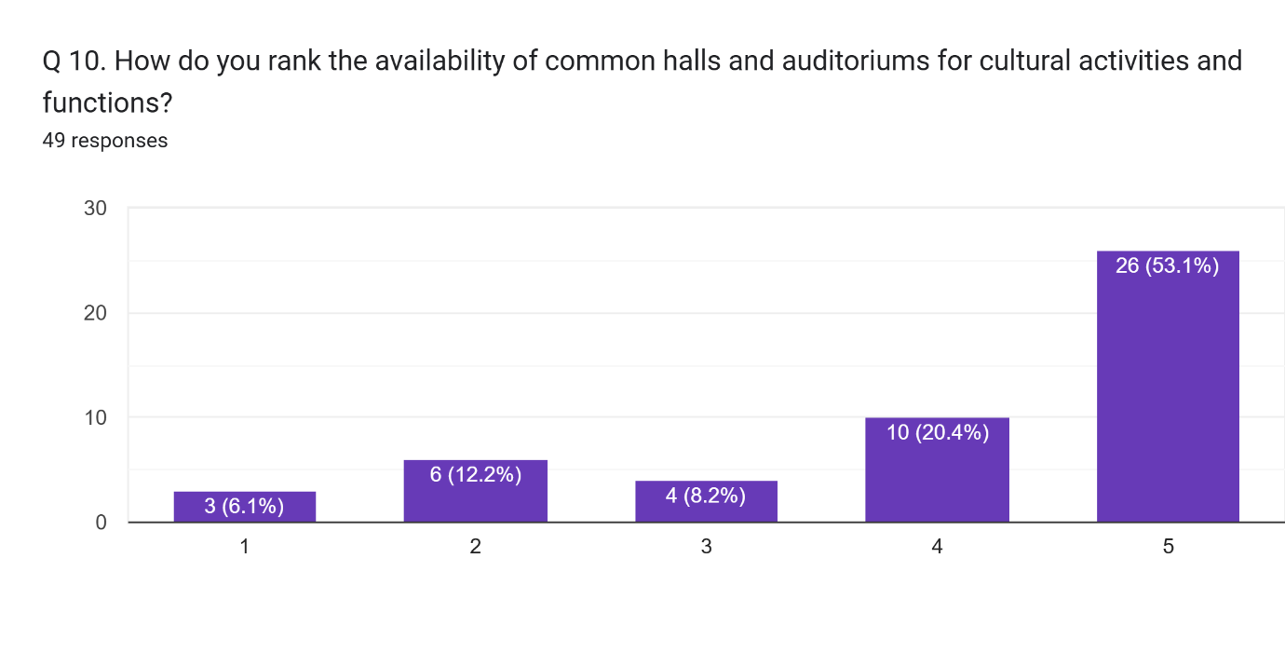

Any other comment which you would like to mention (Please write in space provided here).
19 responses
Good
No
Study
Excellent
College need a all round development in faciliating the infrastructure in class room auditorium and play ground.
Nothing is better than nothing that is given
I am not selected in main campus of allahabad University but when I came Dr shyam Prasad Mukherjee PG College I experienced the world best facilities and teachers are here.. thank you so much my teachers and my College
Nhi
Campus se asantusht
Please run the class continuously without gapping.
Study
Not clean washroom and play ground
Online classes ki suvidha sanchalit kren
No comment
The playground in our college needs some attention

